34.68: The derivations of Eqs. (34.6) and (34.7) are identical for convex mirrors, as long as one recalls that R and 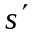 are negative. Consider the diagram below:

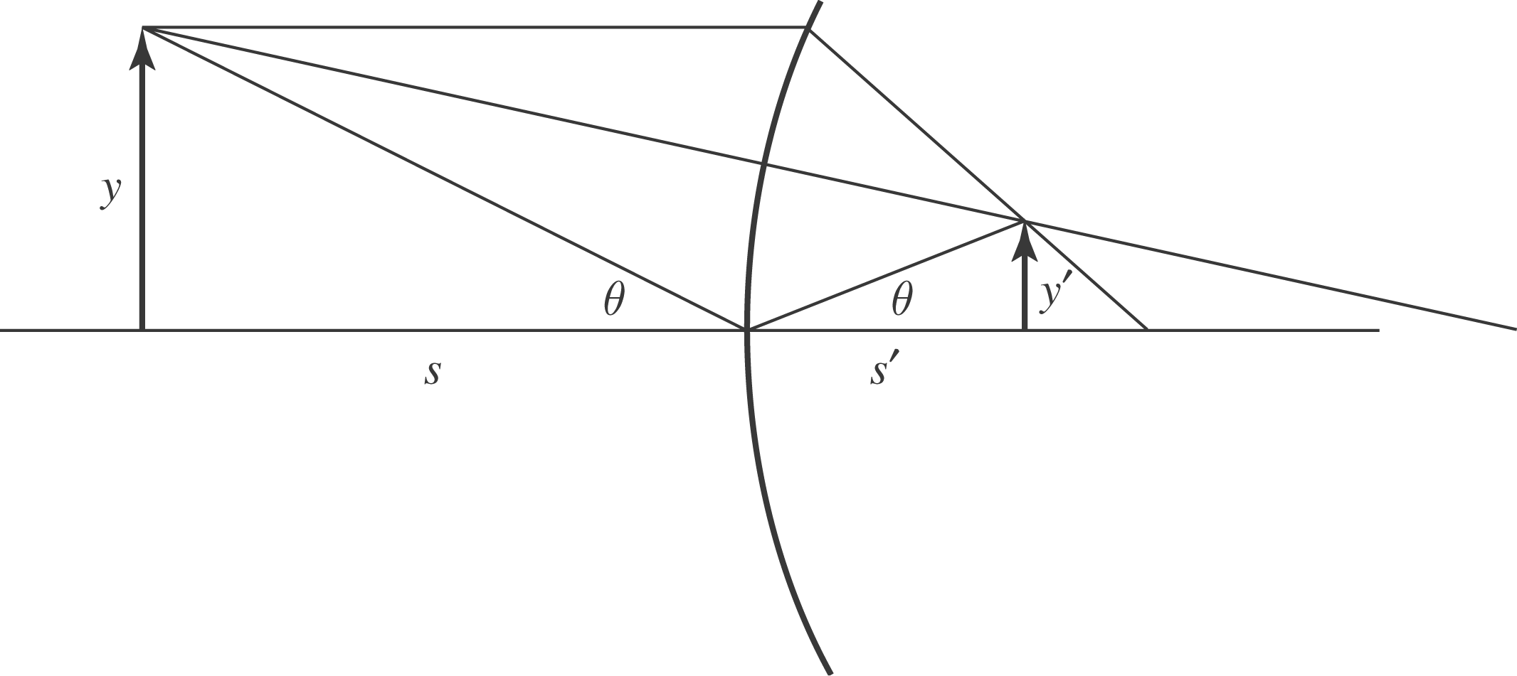
We have: 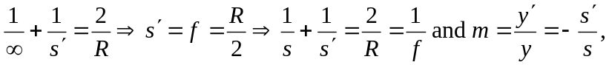 since is not on the outgoing side of the mirror.

